**THESE STEPS ARE ONLY NEEDED IF YOU LOG INTO A BCBSAZ LAPTOP, OTHERWISE DISREGARD.**

**If you do not complete these steps, you will not be able to log into your laptop while offline and risk locking yourself out. This policy is MANDATORY for all users with ADM accounts.**

1. Verify that you are connected to the BCBSAZ network by either being in office or on the VPN.
2. Open Okta Verify Desktop Application

Click Device Access tab Click + One-Time Password  
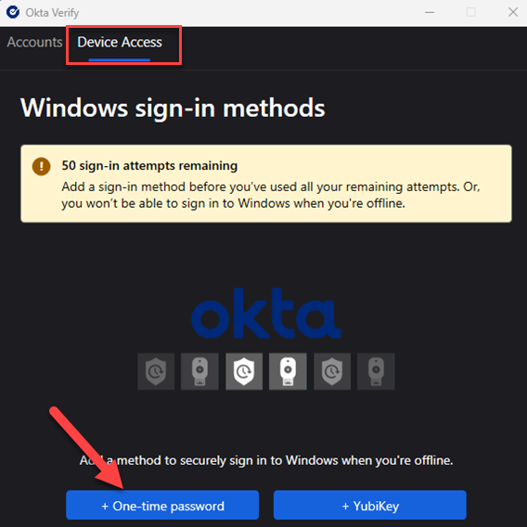

Select “Next” to show the QR Code that you need to scan using Okta Verify

If you are not automatically prompted to setup an account select the "+" on the top right hand corner.

Then select "Organization"

Select "Skip" when asked about adding an account from another device.

Then select "Yes, Ready to Scan"

Then use the device's camera to scan the QR Code to finish setup.

* 1. After Scanning the QR code with the Okta App, enter the number generated by Okta Verify Mobile app below  
     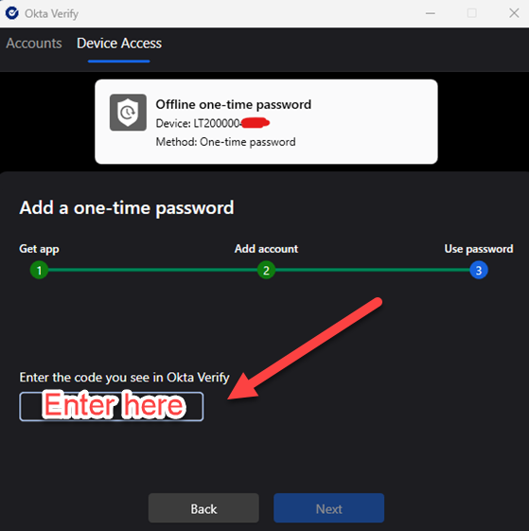
  2. Method added message should show as successful  
     A screenshot of a computer

     Description automatically generated
  3. Restart and attempt to use Okta to login to Windows

**Note**: For iPhone users, upon receiving the first push notification, you must go into the Okta Verify Mobile app and select the number that is displayed on the laptop screen. After the first time, you can just hit the “Yes it's me” button on the Notification banner.

If you have any questions or need help with the enrollment process, please contact the IT Service Desk either via Employee Center, or call (602) 864-4099